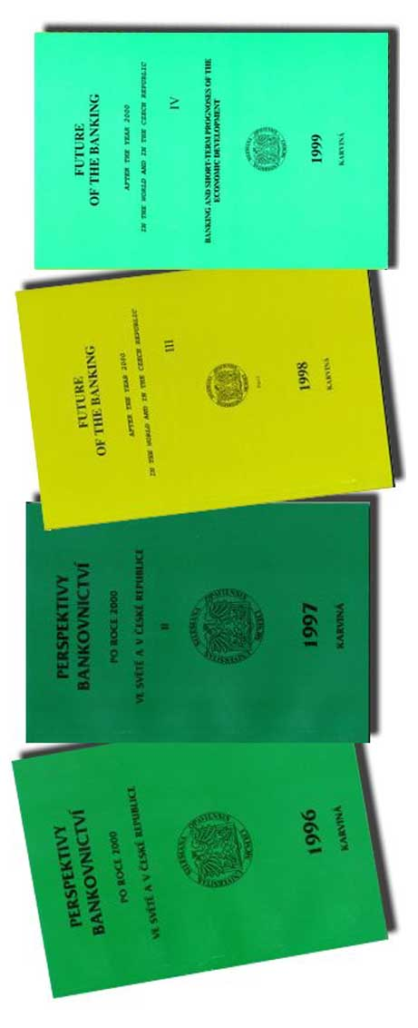

International Program Committee

Chairman: Doc. RNDr. PhDr. Stanislav Polouček, CSc.
Slezská univerzita, Obchodně podnikatelská fakulta, Karviná
Members: Prof. Ing. Karol Vlachynský, CSc.

Národohospodárska fakulta, Ekonomická univerzita, Bratislava, Slovakia
Robert Balik, Ph.D.
Haworth College of Business, Western Michigan University, Kalamazoo, MI, U.S.A.
Prof. dr hab. Halina Henzel
Akademia Ekonomiczna im Karola Adamieckiego, Katowice, Poland
Prof. Ing. Alois Baran, DrSc.
Slezská univerzita, Obchodně podnikatelská fakulta, Karviná

⇒ ⇒ The language of the conference is English, Czech, Slovak and Polish.

⇒ Conference fee: 980,-Kč
(pay on the account no. 101285279/5100, variable symbol 72000 at the latest by 1. 9. 2000)
The fee includes:
Conference contribution CZK 640
Proceedings CZK 180
2x lunch CZK 160
Total CZK 980
Please produce the receipt confirming the payment of the fee at registration.

⇒ On demand we will ensure accommodation, it is not included in the fee.

⇒ The detailed program of the conference will be obtained after the application forms have been collected.

⇒ All information concerning the programme of the conference and the proceedings:

Marcela Beránková
Secretary of Department of Finance
Obchodně podnikatelská fakulta
Slezské Univerzity
Univerzitní nám. 76
733 40 Karviná

- Marcela Beránková, tel.: (069)6398 271
fax: (069)6398 317;
e-mail: berankova@opf.slu.cz
- Lumír Kulhánek, tel.: (069)6398 211
e-mail: kulhanek@opf.slu.cz

⇒ We would like to invite you to our homepage, where, besides others, you will find the photos from the last years’ conferences and also the programme and application form for this year’s conference.

http://www.opf.slu.cz/pb2000

General program of the conference:

WEDNESDAY 18th October 2000
9,00 |  |  | Registration
10,00 |  |  | Introduction
10,15 - 11,45 |  |  | The main papers
10,15 - 11,00 |  |  |  | Jon Locke  Audit Senior Manager  Deloitte&Touche
11,00 - 11,45 |  |  |  | Dr. Jiří Korb, MBA  Managing Director  Duff&Phelps CZ, a.s.
11,45 - 12,15 |  |  | Break
12,15 - 13,30 |  |  | Discussion about the main papers
13,30 - 14,30 |  |  | Lunch
14,30 - 16,30 |  |  | Other Papers
18,00 |  |  | Reception at the premises of OPF
THURSDAY 19th October 2000
8,00 - 12,30 |  |  | Papers and discussion in the sections
 | A: | Audit and rating in the banking sector
 | B: | Macroeconomic circumstances of the operation  of the banking sector
 | C: | Operation mechanism of the banking sector
 | D: | Effects of the banking sector on formation of  business environment
 | E: | Banking sector and the capital market

Silesian University Opava

School of Business Administration Karvina



Future of the Banking
after the Year 2 000 in the World
and
in the Czech Republic
V

AUDIT AND RATING
IN THE BANKING SECTOR

Invitation for the
5TH international conference

18 and 19 October 2000

Silesian University

School of Business Administration

Karviná

APPLICATION
FOR The 5th INTERNATIONAL CONFERENCE

Future of the Banking after the Year 2 000

in the Czech Republic and in the World

18 and 19 October 2000

held at the School of Business Administration

Universitni nam. 76
733 40 Karvina

Name and surname, degree(s):

....…………………………......................................................Workplace:

...................................................……………............................................................................................................................Employer‘s address:
………………………………………………………………
................................................................................................

Telephone:……………….. e-mail:.……..............................

At the seminar I will present in the section A B C D E (please circle) my paper with the topic

..................................................................................................
.................................................................................................

I will submit my paper for the publication in the proceedings printed and on the disc by ……………… (on the day of the start of the conference at the latest)

ANNOTATION

I require – do not require accommodation

Within the days 17-18 October 2000 yes no
18-19 October 2000 yes no

The accommodation is paid on the spot

Information on the proceedings

The papers will be published in the proceedings. Therefore, we ask the authors to submit them on a disk and in writing (processed in Microsoft Word 97 a below) on the beginning day of the conference at the latest, i.e. 18th October 2000. The papers may be sent by e-mail to the address berankova@opf.slu.cz. The papers will be reviewed before their publishing.

Format of the paper:
- Size of page B5 (see File→View of page →Size of paper→ B5 (25x17,6)
- Font Times New Roman size 10
- The paper should not be longer than 15 pages
- Graphs may be inserted only in the form of a picture (see Edit→Insert differently→Type picture)
- We require the paper to be handed in on a disk and one copy in writing

Structure of the paper and its necessary parts:
- Title of the paper Times New Roman 12 bold in English
- Name and workplace of the author Times New Roman 10 bold
- Key words Times New Roman 10 in English
- The text of the paper Times New Roman 10 in English
- Abstract Times New Roman 10 in Czech
- References Times New Roman 10 with numbering [1]...[2] etc.

Please send this application back
by 1st September 2000 at the latest

